

ACTIVITY 2

PROGRAMME: BACHELOR OF COMPUTER APPLICATION
SEMESTER: III
COURSE: ENVIRONMENTAL STUDIES
COURSE CODE: 22ENVI0VE2

Name | USN | Section and Specialization
Chiranth Reddy P | 24BCAR0627 | J & AI
Khaleel Yousuf Khan | 24BCAR0244 | J & AI
Madhav Raj | 24BCAR0317 | J & CS
Pakaton Saowakon | 24BCAR0545 | J & CS
Peer Mohammad Manan Wali | 24BCAR0262 | J & AI

Course Facilitator | Prof. Derrick Rozario
Course Facilitator Signature
Date of Submission | 10-09-2025

1. Introduction

Oil spills are one of the most serious environmental disasters. They occur when petroleum or its products accidentally enter oceans, rivers, or lakes. Oil spreads quickly over water, forming a thin film that prevents oxygen transfer, harms aquatic life, and contaminates coastlines. Cleaning oil spills is often costly and time-consuming.

Our project introduces a low-cost magnetic oil spill cleaner prototype. By attaching iron filings to oil and then using magnets to collect it, we demonstrate a possible eco-friendly solution.

2. Problem Analysis

Scale of the problem: According to UNEP, millions of liters of oil spill into water bodies every year.

Impact:
- Kills fish and aquatic organisms.
- Destroys bird feathers, reducing their ability to fly.
- Pollutes coastlines and affects tourism.
- Long-term contamination of soil and water.

Current solutions:
- Chemical dispersants (harmful to environment).
- Burning oil on water (air pollution).
- Skimming machines (expensive).

Gap: Most current methods are expensive, complex, or environmentally harmful. A simple, low-cost, scalable solution is needed.

3. Proposed Solution
Concept: Use magnetic attraction to separate oil from water.
Oil floats on water and does not mix.
When iron filings are sprinkled on oil, they stick to it.
A magnet can then pull the filings, bringing oil along with them.

Technology Involved:
- Magnetism (basic physics).
- Material science (iron filings + oil interaction).
- Can be scaled using magnetic nanoparticles in real world.

Feasibility:
- Low-cost and simple to demonstrate.
- Requires minimal energy.
- Can inspire future large-scale solutions.

4. Prototype Details

Materials Used:
- Bowl of water
- Cooking oil (2–3 tablespoons, colored with turmeric/food dye for visibility)
- Iron filings (hardware store / filing a nail)
- Magnet (wrapped in plastic sheet for easy cleaning)
- Tissue paper (to remove oil after collection)

Design & Steps:
1. Fill bowl with water.
2. Add oil to create a thin spill layer.
3. Sprinkle iron filings over oil surface.
4. Bring magnet near the filings – oil attaches and moves with magnet.
5. Collect oil + filings on one side and remove.

5. Results

- Observation: Oil layer coated with filings moved strongly toward the magnet.
- Demo hack used: Wrapping magnet in plastic helped show collected oil clearly.
- Outcome: The water surface was visibly cleaner after magnetic removal.
- Testing note: Stronger magnets produced faster and cleaner collection.

6. Reflection

Challenges Faced:
- Weak magnets were slow; stronger ones worked better.
- Some small oil traces remained, showing that this is a partial cleanup.

Potential Improvements:
- Use magnetic nanoparticles instead of filings (research already exists).
- Develop automated boats with rotating magnets to clean large spills.
- Combine with floating booms for large-scale cleanup.

Real-World Applications:
- Ocean and lake oil spill response.
- Small-scale use in harbors, industries, or stormwater drains.

7. Conclusion

Our Magnetic Oil Spill Cleaner prototype demonstrates a low-cost, eco-friendly idea for tackling one of the world’s biggest environmental challenges. While simple, it shows how basic physics (magnetism) can inspire real-world sustainable technologies.

This solution contributes to sustainability by:
- Preventing aquatic life loss.
- Reducing environmental damage.
- Inspiring safer, chemical-free cleanup methods.

8.Photographs:

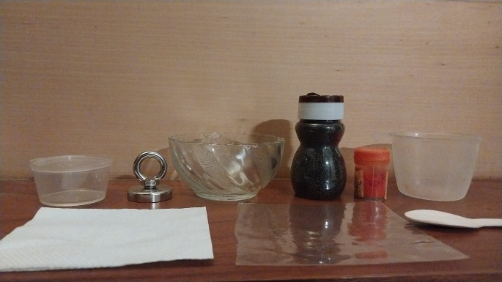 | 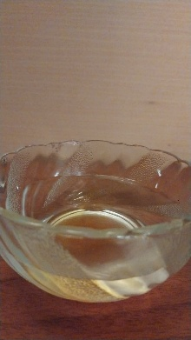
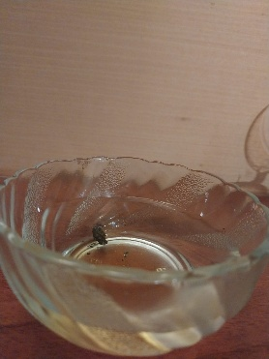 | 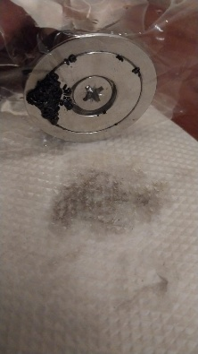
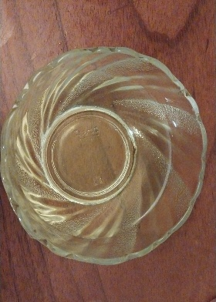 | 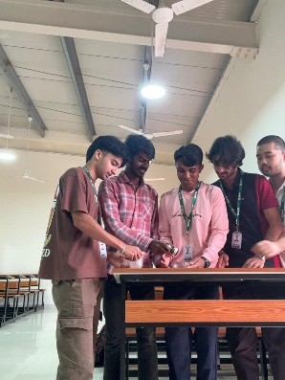

9.Team Details:
Name | USN | Score | Comments
Chiranth Reddy P | 24BCAR0627
Khaleel Yousuf Khan | 24BCAR0244
Madhav Raj | 24BCAR0317
Pakaton Saowakon | 24BCAR0545
Peer Mohammad Manan Wali | 24BCAR0262

Presentation:
Date:

Observation:

